The Change Maker’s Toolkit: Creating Shared Vision and Sustaining Meaningful Change

Since 2015, we have been supporting the work of change leaders attempting meaningful reform in STEM education (National Science Foundation Grant Nos. 1540042, 154072, 1649379, and 1640318). Previous research has suggested that building shared vision increases both trust and participation in the reform project, yet the concept of shared vision has not been operationalized. In addition, strategies for sustaining change have not been translated from organizational theory to academic contexts. This seminar will focus on two specific skills that faculty and administrators need to develop as change leaders on their campuses. In this interactive session, campus leaders will explore strategies for creating a shared vision and sustaining meaningful change initiatives.

Learning Objectives: As a result of this session, attendees will be able to:
- Identify the components of a shared vision for change
- Draft a set of strategies relevant to their own institutional context for creating a shared vision
- Create a sustainability plan for a needed change

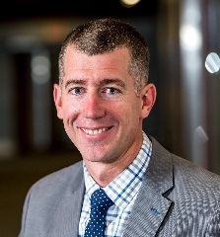
Matt Lovell, Ph.D., P.E.
Associate Professor of Civil Engineering
Interim Executive Director of Institutional Research, Planning, and Assessment
lovellmd@rose-hulman.edu
812-877-8318

Dr. Matthew Lovell obtained his Masters and Ph.D. in Civil Engineering from Purdue University. During his time at Purdue, Matt worked at Bowen Lab gaining experience in large scale experimentation and field instrumentation of structures. He also has experience working as a consultant for a bridge design firm and as the Site Operations Engineer for the Network for Earthquake Engineering Simulation (NEES). Since 2011, Matt has served as an Assistant Professor of Civil Engineering at Rose-Hulman. Dr. Lovell engages his students in undergraduate research experiences and focuses on infusing creative design and structured problem solving in undergraduate engineering courses. He is also an active member of the American Society for Engineering Educators, American Concrete Institute, and American Society of Civil Engineers.


Julia M. Williams, PhD
Interim Dean, Cross-Cutting Programs and Emerging Opportunities
& Professor of English
Rose-Hulman Institute of Technology
Terre Haute, IN
williams@rose-hulman.edu

Julia M. Williams joined the faculty of the Humanities and Social Sciences Department at Rose-Hulman Institute of Technology in 1992, then assumed duties as Executive Director of the Office of Institutional Research, Planning, and Assessment in 2005. In 2016, she was appointed Interim Dean of Cross-Cutting Programs and Emerging Opportunities. In this role, she supports the work of faculty who create multi-disciplinary learning opportunities for Rose-Hulman students. Throughout her career at Rose-Hulman, she has blended her work in the classroom with work in assessment.
Williams’ publications on assessment, engineering and professional communication, and tablet PCs have appeared in the Journal of Engineering Education, IEEE Transactions on Professional Communication, Technical Communication Quarterly, and The Impact of Tablet PCs and Pen-based Technologies in the Classroom, among others. She has been awarded grants from Microsoft, HP, the Engineering Communication Foundation, and NSF. Currently she collaborates with colleagues at Rose-Hulman and at the University of Washington Center for Evaluation & Research for STEM Equity (CERSE) to support the work of the Revolutionizing Engineering and Computer Science Departments (RED) grant recipients. She has received numerous awards including the 2015 Schlesinger Award (IEEE Professional Communication Society), and the 2010 Sterling Olmsted Award (ASEE Liberal Education Division). She is also the recipient of the 2008 Rose-Hulman Board of Trustees Outstanding Scholar Award and the 2004 Humanities and Social Sciences Department Outstanding Researcher Award.

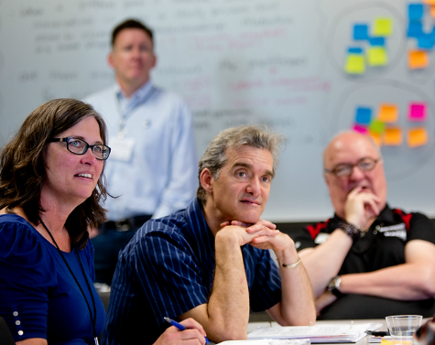
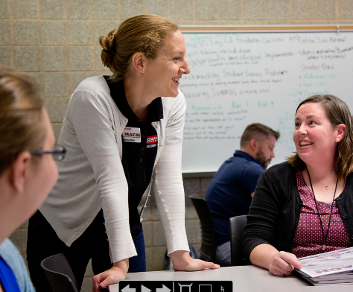
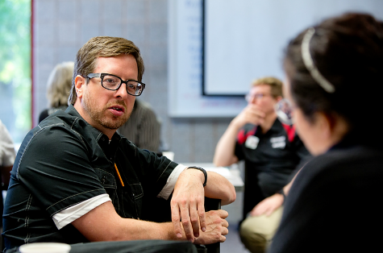
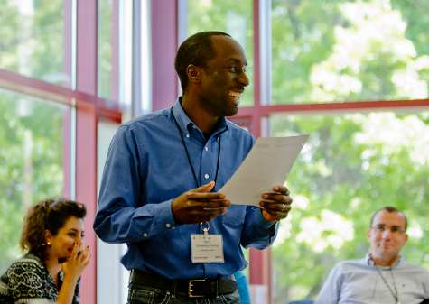

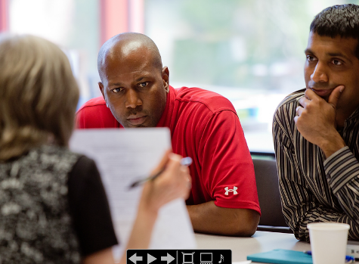

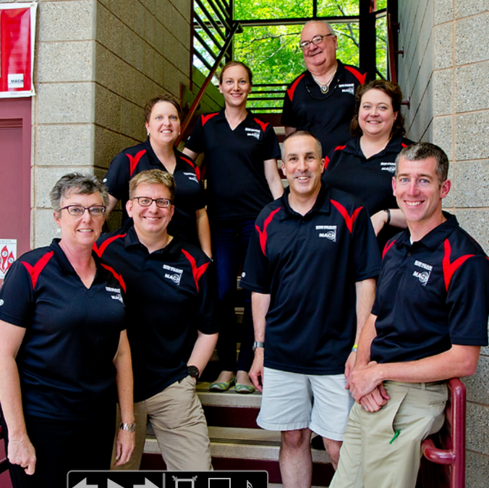
Making Academic Change Happen

MACH grew out of a faculty grassroots effort – to figure out how to make change easier and spread this information to colleagues. Around lunch tables and in small conference rooms, this group developed the core principles that now comprise the MACH approach, all centered on two philosophical points: translating research to practice and learning by doing. Reach out to one of us to learn how MACH can help you and your colleagues become more successful at making change happen on your campus.
www.academicchange.org

back row: Eva Andrijcic and Steve Chenoweth; middle row: Ella Ingram and KC Dee; front row: Julia Williams, Rich House, Glen Livesay, and Matt Lovell; not pictured: Craig Downing & Sriram Mohan
The MACH Team:
Eva Andrijcic, Engineering Management, 812-877-8893, andrijci@rose-hulman.edu
Steve Chenoweth, Computer Science, 812-877-9874, chenowet@rose-hulman.edu
KC Dee, Biomedical Engineering, 812-877-8502, dee@rose-hulman.edu
Craig Downing, Engineering Management, 812-877-8822, downing@rose-hulman.edu
Rich House, English, 812-872-6228, house@rose-hulman.edu
Ella Ingram, Biology, 812-877-8507, ingram@rose-hulman.edu (Current Director)
Glen Livesay, Biomedical Engineering, 812-877-8504, livesay@rose-hulman.edu
Matt Lovell, Civil Engineering, 812-877-8318, lovellmd@rose-hulman.edu (Past Director)
Sriram Mohan, Computer Science, 812-877-8819, mohan@rose-hulman.edu
Julia Williams, English, 812-877-8186, williams@rose-hulman.edu
Briefly describe your project.

In one short phrase, what is the ultimate goal of your project?

List stakeholders who have an interest in your project. | Describe the means of communication you have used to engage these stakeholders with your project.
Faculty
Students
Administrators

Crane and Livesey, 2003:

In the differentiated network model, stakeholder relationships must therefore by understood as a complex interplay of shifting, ambiguous, and contested relationships between and within diverse organizations. This highlights the central role of communication in constituting, managing, and maintaining stakeholder relationships.

In its more genuine forms, one-way communication was designed to persuade its audiences through honest, if rhetorically slanted messages. Two-way asymmetrical models were designed to gather information from the corporation’s publics in order to identify messages most likely to produce attitudes and behaviours the corporation desired. By contrast, symmetrical models were designed to facilitate understanding and communication between parties.

Stakeholder Models: One-way, two-way asymmetrical, symmetrical

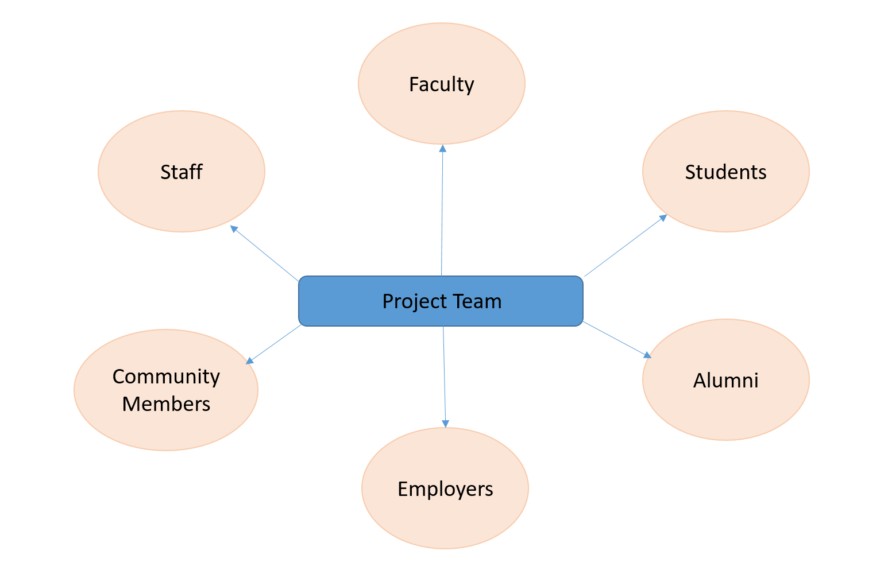

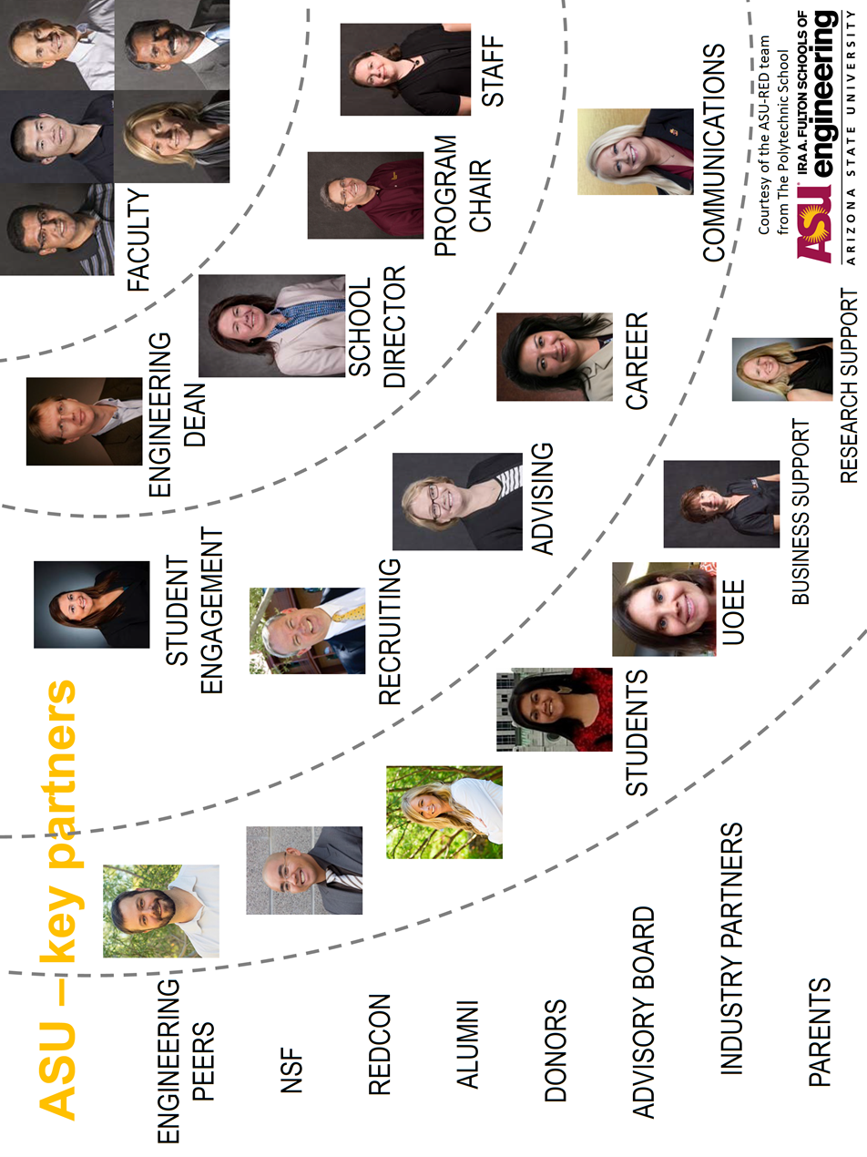

Co-orient stakeholders through communication: by creating a shared language/lexicon for the project together, you provide a way for project leaders and stakeholders to tune into the project and each other.
Target stakeholder—

Establish agency: stakeholders commit more completely to a project when they feel they have a meaningful role to make decisions, implement project activities, possess personal agency.
Target stakeholder—

Co-create project products: rather than deliver project products as complete, co-create products such as curricula, courses, even a contract or syllabus for the ways in which the project team and stakeholders will interact with each other.
Target stakeholder—

Honor what has come before: stakeholders may have emotional connections to previous efforts, both the successes and the failures. Honoring what has come before allows stakeholders to air their concerns, deal with anxiety about the challenges ahead, connect with campus culture.
Target stakeholder—

Notes
________________________________________________________________________________________________________________________________________________________________________________________________________________________________________________________________________________________________________________________________________________________________________________________________________________________________________________________________________________________________________________________________________________________________________________________________________________________________________________________________________________________________________________________________________________________________________________________________________________________________________________________________________________________________________________________________________________________________________________________________________________________________________________________________________________________________________________________________________________________________________________________________________________________________________________________________________________________________________________________________________________________________________________________________________________________________________________________________________________________________________________________________________________________________________________________________________________________________________________________________________________________________________________________________________________________________________________________________________________________________________________________________________________________________________________________________________________________________________________________________________________________________________________________________________________________________________________________________________________________________________________________________________________________________________________________________________

Sustaining Change

Identify your operational unit of change ___________________________________.

Assess the Urgency of your operational unit.

- High Level of Complacency  - Unit Perceives no Threats  - Comfortable with Status Quo |  | - High Level of Urgency  - Unit is Mobilized for Action  - Tackling Threats and Seizing Opportunities

Assess the Guiding Coalition driving your change project.

- Significant Lack of Power  - Lacking Social, Political, HR Leaders.  - Low Credibility among Operational Unit  - Low-Functioning Team  - Lacking Key Points of View |  | - Sufficiently Powerful  - Team Includes Decision Makers, Social, Political, and HR Leaders  - High Credibility among Operational Unit  - High-Functioning Team  - Broad Expertise Represented

Assess the Vision guiding your change project.
- Lack of Concise Vision  - No Clear Plan to Achieve Vision.  - Difficulty to Communicate  - Does not Incorporate Interests of Stakeholders |  | - Clear and Concise Vision  - Vision Supported by Clear and Actionable Strategies  - Easy to Communicate  - Picture of the Future Appealing to Stakeholders

Assess the team’s effectiveness Communicating the Vision for your change project.
- Communication is Infrequent, Singularly Distributed, Complicated  - Behavior of Team Members Inconsistent with Vision  - One-Way Communication  - Stakeholders Lack Understanding of Vision |  | - Utilize Multiple Forums to Communicate Vision and Strategies  - Guiding Coalition Models Expected Behavior Changes  - Opportunities for Two-Way Communication and Feedback  - Stakeholders Understand Vision

Assess if broad-based action is Empowered through your change project.
- Significant Obstacles Exists for those Wish to Adopt Changes  - Structures, Policies, or Management Undermine Change Vision  - Community Lacks Necessary Skills to Implement Change |  | - Obstacles are Removed to Support Adoption of Change  - Risk Taking and Nontraditional Ideas and Activities are Encouraged  - Community is Empowered through Necessary Training

Assess the team’s ability to Generate Short-Term Wins for your change project.
- Incremental Wins are Not Included in Strategies  - Rewards / Commendations are Isolated to a Small Piece of the Team  - Improvements are Recognized by Only a Small Select Group |  | - Wins are Clear and Celebrated Frequently  - Wins are Planned and Created by the Coalition  - Wins are Celebrated Across the Operational Unit

Assess if project gains are leveraged to Produce More Change for your change project.
- Individuals Step Aside after Their Portion is Accomplished  - Coalition Allows a Drop in Urgency  - Team is not Growing |  | - Short-Term Wins are Leveraged for Bigger Initiatives  - Coalition Emphasizes the Shared Long-Term Vision  - New People have been Added to Team

Assess the Cultural Integration of your change project.
- Us versus Them Discourse  - Succession Plans are Ignored  - Lessons Learned Remain Internal to Operational Unit |  | - “[Our Project] is the Way We Do Things”  - Succession Plans are Integral to Project Planning  - Lessons Learned Impact Beyond Operational Unit

After comparing your assessment of your team’s progress toward sustaining change with the assessment of your teammates brainstorm together on the following:

- How could our team increase the Urgency of our operational unit?
- Who should be added to our Guiding Coalition to increase its influence?
- How can our Vision and supporting strategies be improved for clarity and simplicity?
- What is a new way that our team can Communicate the Vision of our change project?

Removing Barriers and Empowering the Operational Unit
Identify any former, current, or anticipated barriers to your change project.
Structural Barriers  Siloed departments stifle cross-disciplinary course offerings. | Skillset Barriers  Faculty require training for effective feedback for writing assignments.
System Barriers  Promotion and tenure criteria do not align with change activities. | Supervisor Barriers  Senior, influential faculty member is publically in opposition to the project.

- How can the structures of the institute be made compatible with the vision?

- What training do we need to provide the appropriate knowledge, skills, and attitudes?

- How can the systems of the institute be aligned to the vision?

- How might we confront/engage influential, oppositional faculty members to minimize their impact?

Generating Short-Term Wins

In your own words, what would success look like for your change project?
Identify three short-term wins that your team can facilitate on the way toward achieving the vision. What strategies can be implemented to ensure that this win occurs? A good short term win is
- Visible – A large number of people can see that this win is real and not just hype.
- Unambiguous – There is little to no argument that this is a real win.
- Connected – The win is clearly tied to the change initiative.

Win #1: 0 to 6 months
Win #2: 6 to 12 months

Win #3: 12 to 24 months
Notes
________________________________________________________________________________________________________________________________________________________________________________________________________________________________________________________________________________________________________________________________________________________________________________________________________________________________________________________________________________________________________________________________________________________________________________________________________________________________________________________________________________________________________________________________________________________________________________________________________________________________________________________________________________________________________________________________________________________________________________________________________________________________________________________________________________________________________________________________________________________________________________________________________________________________________________________________________________________________________________________________________________________________________________________________________________________________________________________________________________________________________________________________________________________________________________________________________________________________________________________________________________________________________________________________________________________________________________________________________________________________________________________________________________________________________________________________________________________________________________________________________________________________________________________________________________________________________________________________________________________________________________________________________________________________________________________________________

References for Applicable Strategies

Buller, J.L. 2015. Change Leadership in Higher Education: A Practical Guide to Academic Transformation. Jossey-Bass, San Francisco.
Collins, J. 2005. Good To Great and the Social Sectors. Harper Collins, New York, NY.
Eckel, P.D., M. Green, B. Hill, & W. Mallon. 1999. On change III. Taking charge of change: A primer for colleges and universities. American Council on Education, Washington, DC.
Eckel, P.D. & M. Hartley. 2008. Developing academic strategic alliances: Reconciling multiple institutional cultures, policies, and practices. The Journal of Higher Education 79(6): 613-637.
Eddy, P.A., & M.J. Amey. 2014. Creating Strategic Partnerships: A Guide for Educational Institutions and Their Partners. Stylus Publishing, Sterling, VA.
Goldstein, N.J., S.J. Martin, & R.B. Cialdini. 2008. Yes: 50 Scientifically Proven Ways to Be Persuasive. Free Press, New York, NY.
Grenny, J., K. Patterson, D. Maxfield, R. McMillan, & A. Switzler. 2013. Influencer: The New Science of Leading Change. McGraw-Hill Education, New York, NY.
Harvard Business Review. 2013. On Teams. Harvard Business Review Press, Boston, MA.
Kotter, J.P. 2012. Leading Change. Harvard Business Review Press, Boston, MA.
Kotter, J.P. & L.A. Whitehead. 2010. Buy-In: Saving Your Good Idea From Getting Shot Down. Harvard Business Review Press, Boston, MA.
Stone, D., B. Patton, & S. Heen. 2010. Difficult Conversations. Penguin Books, New York, NY.

Reference for Theoretical Base

Bolman, L.G. & T.E. Deal. 2013. Reframing Organizations: Artistry, Choice, and Leadership (5th ed.). Jossey-Bass, San Francisco, CA.
Brown, A.D., S. Ainsworth, and D. Grant. 2012. The rhetoric of institutional change. Organizational Studies. 33: 297-321.
Crane, A. and S. Livesey. 2003. Are you talking to me? Stakeholder communication and the risks and rewards of dialogue. In J. Andriof, S. Waddock, S. Rahman, and B. Husted, eds. Unfolding stakeholder thinking 2: relationships, communication, reporting, and performance. Sheffield: Greenelaf, 39-52.
Fumasoli, T. & B. Stensaker. 2013. Organizational studies in higher education: A reflection on historical themes and prospective trends. Higher Education Policy 26: 479-496.
Gumport, P.J. 2000. Academic restructuring: Organizational change and institutional imperatives. Higher Education 39(1): 67-91.
Henderson, C., A. Beach, & N. Finkelstein. 2011. Facilitating change in undergraduate STEM instructional practices: An analytic review of the literature. Journal of Research in Science Teaching 48(8): 952-984.
Kezar, A. & J. Lester. 2009. Supporting faculty grassroots leadership. Research in Higher Education 50(7): 715-740.
Kezar, A. 2014. How Colleges Change: Understanding, Leading, and Enacting Change. Routledge, New York.
Kezar, A. & P.D. Eckel. 2002. The effect of institutional culture on change strategies in higher education: universal principles or culturally responsive concepts? The Journal of Higher Education 73(4): 435-460.
McClellan, J.G. 2014. Announcing change: Discourse, unvertainty, and organizational control. Journal of Change Management. 14 (2): 192-209
Morsing, M. and M. Schultz. 2006. Corporate social responsibility community: stakeholder information, response, and involvement strategies. Business Ethics: A European Review. 15 (4): 323-38.
Vaira, M. 2004. Globalization and higher education organizational change: A framework for analysis. Higher Education 48(4):483-510.

Schedule At-A-Glance – Making Academic Change Happen 2017
www.rose-hulman.edu/MACH

